 

**DESIGN AND FABRICATION OF SOLAR DRYER**

#### A PROJECT REPORT

*Submitted by*

|  |  |
| --- | --- |
| **RAJARAM G** | **721820114013** |

***in Partial fulfillment for the award of the degree***

***of***

**BACHELOR OF ENGINEERING**

in

**MECHANICAL ENGINEERING**

#### RATHINAM TECHNICAL CAMPUS COIMBATORE - 641 021

**ANNA UNIVERSITY: CHENNAI 600 025**

**APRIL/MAY - 2023**

### DESIGN AND FABRICATION OF SOLAR DRYER

#### A PROJECT REPORT

*Submitted by*

|  |  |
| --- | --- |
| **RAJARAM G** | **721820114013** |

***in Partial fulfillment for the award of the degree of***

**BACHELOR OF ENGINEERING**

in

**MECHANICAL ENGINEERING**

#### RATHINAM TECHNICAL CAMPUS COIMBATORE - 641 021

**ANNA UNIVERSITY: CHENNAI 600 025**

**APRIL/MAY - 2023**

### ANNA UNIVERSITY: CHENNAI 600 025

**BONAFIDE CERTIFICATE**

Certified that this project report **“ DESIGN AND FABRICATION OF SOLAR DRYER”** is the bonafide work of **“ RAJARAM G (721820114013)’’** who carried out the project work under my supervision.

#### SIGNATURE SIGNATURE

Mr A.Thirumoorthy,

Supervisor,

Assistant Professor,

#### Department of Mechanical Engineering,

Rathinam Technical Campus,

Coimbatore-641021.

#### Mr G. Vijayaseakaran,

#### Professor,

#### Head of The Department,

#### Department of Mechancal Engineering ,

#### Rathinam Technical Campus,

Coimbatore-641021.

Submitted for the viva – voce examination held on ………….

#### INTERNAL EXAMINER EXTERNAL EXAMINER

**ACKNOWLEDGEMENT**

The success of work depends on the team and its co-operation. We take this opportunity to express our gratitude and sincere thanks to everyone who helped us in our project. First and foremost, we would like to thank the Management for the excellent infrastructure, facilities and the constant support provided for the successful completion for the project work. first and foremost, we would like to thank the Management for the excellent infrastructure, facilities and the constant support provided for the successful completion for the project work.

We wish to express our heartfelt thanks and deep sense of gratitude to our chairman

**Dr. MADAN A SENDHIL M.S.,Ph.D,** , for his valuable guidance and continuous support.

Our sincere thanks to honorable Principal **Dr. B. NAGARAJ M.E., Ph.D**., for giving us the opportunity to display our professional skills through this project.

Our special thanks to **Prof. K.S. SATHISH KUMAR B.E., M.E., M.B.A.**, **MISTE., MIIPE.,** Director Academics for his valuable guidance, continuous support and suggestions to improve the quality of the project work.

We express our sincere thanks to our Head of The Department **Prof. G. VIJAYASEKARAN B.E, M..E, (PhD),** for his valuable guidance insightful and continuous support to carry out the project work.

We express our deep sense of gratitude to our guide, **Prof. A.THIRUMOORTHY M.E.,** and all the faculty members of the supporting staff for their continuous support in completing this project work successfully.

## CONTENTS

**TOPICS Page No**

CERTIFICATE....…………………………………………………….. ii

ACKNOWLEDGEMENT……………………………………………. iii

TABLE OF CONTENT………………………………………………. iv

LIST OF FIGURES .......................………………………………….... vi

LIST OF TABLES…….……………………………………………..... vii

ABSTRACT …………….…………………………………………....... 1

1. PROJECT IDENTIFICATION....................................................... 2

1.1 PROJECT IDENTIFICATION…………………………………………....... 3

1.2 PROJECT STATEMENT………………………………...………………… 4

1.3 CONCEPT GENERATION………………………………..……………….. 4

1.4 IMPORTANCE OF SOLAR FRUIT DRYER………………......................... 5

1.5 CLASSIFICATION OF SOLAR FRUIT DRYER………………..………… 6

1.6 CONCEPTUAL DRAWING OF SOLAR FRUIT DRYER…........................ 7

1.7 OBJECTIVE OF SOLAR FRUIT DRYER………………………………….. 8

1.8 APPLICATION OF SOLAR FRUIT DRYER………………………………. 8

**2.LITERATURE REVIEW………………………………….. 9**

|  |  |
| --- | --- |
| **3.METHODOLOGY AND IMPLIMENTATION………..** | **14** |
| 3.1 MATERIALS AND TOOLS OF SOLAR FRUIT DRYER………….…….. | 15 |
| 3.2 OVERVIEW OF SOLAR DRYER ……………………............................... | 16 |
| 3.2.1 CONSTRUCTION OF SOLAR FRUIT DRYER………....................... | 16 |
| 3.2.2 COMPONENTS OF SOLAR FRUIT DRYER………...……………… | 16 |
| 3.2.3 ORIENTATION OF SOLAR FRUIT DRYER…………...…………… | 17 |
| 3.3 OPERATION OF SOLAR FRUIT DRYER………………………………... | 17 |
| 3.4 DESIGN…………………………………………………………………….. | 18 |
| 3.5 DESIGNCONSIDERATION…………………………………….................. 20 | |

**4.CALCULATION................................................................... 21**

**5.FABRICATION AND ASSEMBLING .............................. 24**

**6.PROJECT COST CALCULATION………….....……….. 29**

**7.TESTING…………………………………………………... 31**

**8.CONCLUSION……………………………………………..** 34

**9.REFRENCE..……………………………………………….** 36

## LIST OF FIGURES

**FIGURE NO**  **NAME** **PAGE NO**

|  |  |  |
| --- | --- | --- |
| 1 | Classification of Solar Dryer | 6 |
| 2 | Drawing of Solar fruit dryer | 7 |
| 3 | Overview Dryer | 10 |
| 4 | Schematic Diagram | 19 |
| 5    6 | Assembly Picture  Final project photo | 19  37 |
|  |  |  |

**LIST OF TABLES**

**TABLE. NO NAME PAGE NO**

|  |  |  |
| --- | --- | --- |
| 1 | Different solar Irradiance | 4 |
| 2 | Bill ofMaterial | 15 |
| 3 | Inside temperature of solar dryer | 32 |
| 4 | Different Temperature at trays | 33 |
|  |  |  |

## ABSTRACT

The solar dryer uses solar energy to heat the air and to dry the food product which is very useful

in reducing unwanted product and helps in drying the food product. Considering the natural sun drying,

exposing to direct sunlight, to protect the insects from the food product and increase the time of drying, and to save the cost of the mechanical dryer, a solar dryer is therefore developed to overcome for this limitation.

This project presents the design, construction and performance of solar dryer for food preservation. In the dryer the air from the copper tubes & ETC tubes was passed to the Drying cabinet, at the same time the air gets heated while flowing through the tubes. Inside the drying cabinet the heated dries the product placed on the drying trays. The results obtained during the test shows that the temperatures inside the drying cabinet and solar panel was higher than the atmospheric temperature during the day light. The temperature rise inside the drying cabinet was up to 91°C after 12.00hr (noon). The dryer helps to dry food products more rapidly to a required moisture level and it ensures a best quality of the dried product.

# CHAPTER 1

# PROJECT IDENTIFICATION

**CHAPTER 1**

**1.1 PROJECT IDENTIFICATION**

Agricultural and other products have been dried by the sun and wind in the open air for thousands

of years. The purpose is either to preserve them for later use, as is the case with fruit; or as an integral part of the production process, as with timber, tobacco and laundering. In industrialized regions and sectors, open air-drying has now been largely replaced by mechanized dryers, with boilers to heat incoming air, and fans to force it through at a high rate. Mechanized drying is faster than open-air drying, uses much less land and usually gives a better and quality product. But the equipment is expensive and requires substantial quantities of fuel or electricity to operate.

Solar fruit dryer are simple devices to heat fruit chips by utilizing solar energy and employed in many applications requiring low to moderate temperature below 80oDrying processes play an important role in the preservation of agricultural products.

'Solar drying' in the context of this technical brief, refers to methods of using the sun's energy for drying, but excludes open air 'sun drying'. The justification for solar dryers is that they may be more effective than sun drying, but have lower operating costs than mechanized dryers. A number of designs are proven technically and while none are yet in widespread use, there is still optimism about their potential.

The solar dryer can be seen as one of the solutions to the world’s food and energy crises. With drying, most agricultural produce can be preserved and this can be achieved more efficiently through the use of solar dryers.

Thus the solar dryer is one of the many ways of making use of solar energy efficiently in meeting man’s demand for energy and food and fruit supply, total system cost is a most important Consideration in designing a solar dryer for agricultural uses. No matter how well a solar system operates, it will not gain widespread use unless it presents an economically feasible alternative to other available energy sources.

**1.2 PROJECT STATEMENT**

To design and develop a solar fruit dryer which dries various fruit chips with application of only a small amount of effort and use of Solar energy.

**1.3 CONCEPT GENERATION**

The idea of using solar energy to produce high temperature dates back to ancient times. The solar radiation has been used by man since the beginning of time for heating his domicile, for agricultural purposes and for personal comfort. Reports abound in literature on the 18th century works of Archimedes on concentrating the sun’s rays with flat mirrors; Modern research on the use of solar energy started during the 20th century. Developments include the invention of a solar boiler, small powered steam engines and solar battery, but it is difficult to market them in competition with engines running on inexpensive gasoline. During the mid-1970’s shortages of oil and natural gas, increase in the cost of fossil fuels and the depletion of other resources stimulated efforts in the United States to develop solar energy into a practical power source. Thus, interest was rekindled in the harnessing of solar energy for heating and cooling, the generation of electricity and other purposes.

TABLE 1.1 – DIFFERENT SOLAR IRRADIANCE

|  |  |  |  |
| --- | --- | --- | --- |
|  | Clear, blue sky | Scattered clouds | Overcast sky |
| Solar irradiance[W/m2] | 1300 -1400 | 800 - 1000 | 300 - 400 |
| Diffuse fraction [%] | 10 – 20 | 20 - 80 | 80 - 100 |

**1.4 IMPORTANCE OF SOLAR DRIED FRUITS**

For centuries, people of various nations have been preserving fruits, other crops, meat and fish by drying. Drying is also beneficial for hay, copra, tea and other income producing non-food crops. With solar energy being available everywhere, the availability of all these farm produce can be greatly increased. It is worth noting that until around the end of the 18th century when canning was developed, drying was virtually the only method of food preservation.

Ikejo for stated that the energy input for drying is less than what is needed to freeze or can, and the storage space is minimal compared with that needed for canning jars and freezer containers. It was further stated that the nutritional value of food is only minimally affected by drying.

Also, food scientists have found that by reducing the moisture content of food to 10 to20%, bacteria, yeast, mold and enzymes are all prevented from spoiling it (Microorganisms are effectively killed when the internal temperature of food reaches 145°F. The most of the nutritional value of dried food is preserved and concentrated. Dried foods do not require any special storage equipment and are easy to transport. Dehydration of vegetables and other food crop by traditional methods of open-air sun drying is not satisfactory, because the products deteriorate rapidly, studies showed that food items dried in a solar dryer were superior to those which are sun dried when evaluated in terms of taste colour and counts.

Solar dried fruits are quality products that can be stored for extended periods, easily transported at less cost while still providing excellent nutritive value. This project work therefore presents the design and construction of a domestic solar dryer.

**1.5 CLASSIFICATION OF SOLAR FRUIT DRYER**

To classify the various types of solar dryer, it is necessary to simplify the complex construction and various modes of operation to the basic principles. Solar dryer can be classifying based on following criteria:

* Mode of air movement
* Exposure to insulation
* Direction of air flow
* Arrangement of dryer
* Status of solar contribution

Solar dryer can classify primarily according to their heating modes and the manner in which the solar heat is utilized. In broad terms, they can be classifying into two major groups, namely:

1. Active solar-energy drying system

2. Passive solar-energy drying system



 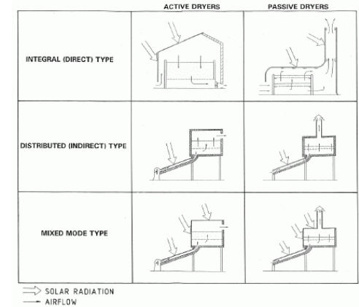



FIGURE 1.1 – CLASSIFICATION OF SOLAR DRYER

**1.6 CONCEPTUAL DRAWING OF SOLAR FRUIT DRYER**

# 

# FIGURE 1.2 - DRWAINFG OF SOLAR DRYER

**1.7 OBJECTIVE OF SOLAR FRUIT DRYER**

The objectives of this project are:

* To create 2D and 3D model of solar fruit dryer
* To design and construct a solar dryer.
* To evaluate the solar dryer’s performance
* To protect the product against flies, pests, rain and dust.
* It is labour saving. The product can be left in the dryer overnight or during rain.
* To achieve better quality of product in terms of nutrients, hygiene and colour.
* To improve family nutrition because fruit and vegetables contain high quantities of vitamins, minerals and fibers
* To improve the bargaining position of farmers.
* To encourage people to establish their own gardens.

**1.8 APPLICATION OF SOLAR FRUIT DRYER**

* Agricultural crop drying.
* Food processing industries for dehydration of fruits and vegetables.
* Fish and meat drying.
* Dairy industries for production of milk powder.
* Seasoning of wood and timber.

**CHAPTER 2**

**LITERATURE**

**REVIEW**

**CHAPTER 2**

**2.1 LITERATURE REVIEW OF SOLAR DRYER**

In many parts of the world there is a growing awareness that renewable energy has an important role to play in extending technology to the farmer in developing countries to increase their productivity. Solar thermal technology is a technology that is rapidly gaining acceptance as an energy saving measure in agriculture application. It is preferred to other alternative sources of energy such as wind and shale, because it is abundant, inexhaustible, and non-polluting

The application of dryers in developing countries can reduce post-harvest losses and significantly contribute to the availability of fruit in these countries. Estimations of these losses are generally cited to be of the order of 40% but they can, under very adverse conditions, be nearly as high as 80%. A significant percentage of these losses are related to improper and/or untimely drying of fruit chips such as banana, mango. apple, etc.

The simplest design for a solar dryer was developed by the Brace Research Institute, Canada, (1975). It is essentially a hot box where fruits, vegetables or other materials can be dehydrated on a small scale.

The construction of such a dryer can take many forms. Nevertheless, certain specifications were recommended. The experimental results at Kanpur, India for the drying of fruits and vegetables showed that solar-drying saved considerable time compared. With sun-drying in the open. Also, the product obtained from the solar dryer was found to be superior in taste and outdoor to sun-dried produce and was not contaminated by dust or infested by insects. Bahnasawy and Shenana (2004) developed a mathematical model of direct sun and solar drying of some fermented dairy products. The main components of the equations describing the drying system were solar radiation, heat convection, heat gained or lost from the dryer bin wall and the latent heat of moisture evaporation. The model was able to predict the drying temperatures at a wide range of relative humidity values. It also has the capability to predict the moisture loss from the product at wide ranges of relative humidity values, temperatures and air velocities.

Soponronnarit (1995) reviewed the research and development work in solar drying Conducted in Thailand during the past 15 years (since 1980s). He found that, in terms of techniques and economy, solar drying for some crops such as paddy, multiple crops and fruit is feasible. However, the method has not been widely accepted by farmers. Most of the solar air heaters developed in Thailand has used modifications to the building roofs. Both bare and glass-covered solar air heaters were reported to be technically and economically feasible when compared to electricity but have not been able to compete with fuel oil.

Pangavhen, et al. (2002) proposed a design, development and performance testing of new convection solar dryer, the solar dryer is capable of producing average temperature between 50 and 55°C, which was optimal for dehydration of grapes as well as for most of the fruits and vegetables. This system was capable of generating an adequate natural flow of hot air to enhance the drying rate. The drying airflow rate increases with ambient temperature by the thermal buoyancy in the collector. The collector efficiencies ranged between 26% for mass flow rate of 0.0126 kg/s of air and 65% for mass flow rate of 0.0246 kg/s. This was sufficient for heating the drying air. The drying time of grapes was reduced by 43% compared to the open sun drying.

Ekechukwu and Norton (1999) presented a comprehensive review of the various designs, details of construction and operational principles for a variety of practical solar-energy drying systems. The appropriateness of each design type for applications used by rural farmers in developing countries was discussed. Sebaii, et al. (2002) reported a study of an indirect type natural convection solar which Investigated experimentally and theoretically for drying grapes, figs, onions, apples, tomatoes and green peas. The drying constants for the selected crops were obtained from the experimental results and were then correlated with the drying product temperature. Linear correlation between drying constant and product temperature were proposed for the selected crops.

The empirical constants of Henderson’s equation were obtained for all the materials from investigation, which are not available in the literature. The proposed empirical correlation suggested that it could well describe the drying kinetics of the selected crops. Gallali, et al. (2000) reported the result of an investigation of some dried fruit and Vegetables based on chemical analysis (vitamin C, total Reducing sugars, acidity, moisture, and ash content) and sensory evaluation data (colour, flavour, andtexture). They compared products dried by solar dryers and natural sun drying. The study indicated that using solar dryers gives more advantages than natural sun drying, especially in terms of drying time.

Karathanos and Belessiotis (1997) reported the sun and solar air drying kinetics of some agricultural products, i.e. sultana grapes, currants, figs, plums and apricots. The drying rates were found for both solar and industrial drying operations. Air and product temperatures were measured for the entire industrial drying process. It was shown that most materials were dried in the falling rate period. Currants, plums, apricots and jigs exhibited two drying rate periods, a first slowly decreasing (almost constant) and a second fast decreasing (falling) drying rate period. In addition, they indicated that the industrial drying operation resulted in a product of superior quality compared to products dried by solar dehydration. Leon, et al. (2002) presented a review of existing evaluation methods and the parameters generally considered for evaluation of solar fruit dryers. These parameters can be classified as: (i) physical features of the dryers; (ii) thermal performance; (iii) quality of dried product; (iv) cost of dryer and payback period.

1. Physical features of dryer:

* Type, size, and shape.
* Collector area and solar aperture.
* Drying capacity/loading density (kg/unit aperture area).
* Tray area and number of layers.
* Loading/unloading convenience.
* Loading/unloading time.
* Handling, cleaning, maintenance convenience and ease of construction

1. Thermal performance:

* Drying time/drying rate up to 10% product moisture content (db.), (this may, however, vary from product to product).
* Dryer/ drying efficiency until product moisture content reaches 10% (db.).
* First day drying efficiency.
* Drying air temperature and relative humidity.
* Maximum drying temperature at no-load and with load.
* Duration of drying air temperature10°C above ambient.
* Airflow rate

1. Quality of dried products:

* Sensory quality (colour, flavour, taste, texture, aroma)
* Nutritional attributes - quantified for easy comparison
* Rehydration capacity - consistency in presentation
* Uniformity of drying

.

##### CHAPTER 3

##### 

##### METHODOLOGY

##### AND

##### IMPLEMENTATION

##### CHAPTER 3

##### 3.1 MATERIALS AND TOOLS OF SOLAR FRUIT DRYER

##### 3.1.1 The following materials were used for the construction of the domestic passive solar

##### Fruit dryer.

##### Wood - as the casing (housing) of the entire system; wood was selected being a good insulator and relatively cheaper than metals.

##### Glass - as the solar collector cover and the cover for the drying chamber. It permits the solar radiation into the system but resists the flow of heat energy out of the systems.

##### Aluminium sheet of 27 gauge thickness and aluminium painted black – for absorption of solar radiation.

##### Wooden frames for constructing the trays.

##### Nails and glue as fasteners and adhesives.

##### Hinges and handle for the dryer’s door

##### Paint (black).

##### 

##### 3.12 BILL OF MATERIAL

##### TABLE 3.1 – BILL OF MATIRIAL

|  |  |  |  |
| --- | --- | --- | --- |
| SR NO | COMPONANT | MATERIAL | DIMENSION(mm) |
| 1 | Solar Collector | Glass | 190x230 |
| 2 | Drying Chamber | Wood | 800x600 |
| 3 | Insulation | Glass wool | 30x160 |
| 4 | Tray | Wood | 800x600 |
| 5 | Roof | Wood | 400x400 |

##### 

##### 3.1.3 the following tools are used in the construction of solar fruit drye

##### Hand saw or skill saw, if available

##### Hammer

##### Tape measure

##### Framing square or tri-square

##### Wood rasp

##### Screw driver

##### Tin snips 23

##### Staple gun

##### Keyhole saw

##### Paint brush

##### Chalking gun

##### Scissors

##### Pencils

##### Soaking pan

##### 3.2 OVERVIEW OF SOLAR DRYING

##### 3.2.1 CONSTRUCTION OF SOLAR FRUIT DRYER

##### The materials used for the construction of the mixed-mode solar dryer are cheap and easily obtainable in the local market. The solar dryer consist of the solar collector (air heater), the drying cabinet and drying trays.

##### 3.2.2 SOLAR FRUIT DRYER COMPONENTS

##### Drying chamber:

##### The drying chamber was made up highly polished wood wish consist of three drying trays also made of wood, the material has been chosen since wood is a poor conductor of heat and its smooth surface finish and also heat loss by radiation is minimized.

##### Heating chamber

##### It consists of following components:

##### Cover plate, absorber plate, insulation.

##### Cover plate:

##### 

##### This is a transparent sheet used to cover the absorber, thereby preventing dust and rain from coming in contact with the absorber, it also retard the heat from escaping, common Materials used for cover plates are glass, fiber glass, flexi glass, but the material used for this Project is glass.

##### Absorber plate:

##### This is a metal painted black and placed below the cover to absorb, the incident solar radiation transmitted by cover thereby heating the air between it and the cover, here aluminium is chosen because its quick response in absorption of solar radiation and also copper because of its good ability to keep the absorbed solar radiation.

##### Insulation:

##### This is used to minimize heat loss from the system, it is under the absorber plate, the insulator can withstand stagnation temperature, it is fire resistant and not subject to out-going gassing and it is damageable by moisture or insect, insulating materials are usually fibre glass, mineral wool, Styrofoam and urethanes, but here Styrofoam was chosen.

##### 3.2.3 THE ORIENTATION OF THE SOLAR COLLECTOR

##### The flat-plate solar collector was always tilted and oriented in such a way that it receives maximum solar radiation during the desired season of used. The best stationary orientation is due south in the northern hemisphere and due north in southern hemisphere. Therefore, solar collector in this work is oriented facing south and tilted at 17.11º to the horizontal. This is approximately 10 º more than the local geographical latitude (Abeokuta a location in Nigeria, 7.11ºN), which according to (Adegoke and Bolaji 2000), is the best recommended orientation for stationary absorber. This inclination is also to allow easy run off of water and enhance air circulation.

##### 3.3 OPERATION OF SOLAR FRUIT DRYER

##### The dryer is a passive system in the sense that it has no moving parts. It is energized by the sun’s rays entering through the collector glazing. The trapping of the rays is enhanced by the inside surfaces of the collector that were painted black and the trapped energy heats the air inside the collector. The greenhouse effect achieved within the collector drives the air current through the drying chamber. If the vents are open, the hot air rises and escapes through the upper vent in the drying chamber while cooler air at ambient temperature enters through the lower vent in the collector. Therefore, an air current is maintained, as cooler air at a temperature Ta enters through the lower vents and hot air at a temperature T e leaves through the upper vent.

##### When the dryer contains no items to be dried, the incoming air at a temperature ‘Ta’ has relative humidity ‘Ha’ and the out-going air at a temperature ‘Te’, has a relative humidity ‘He’. Because Te > Ta and the dryer contains no item, Ha > He. Thus there is tendency for the out-going hot air to pick more moisture within the dryer as a result of the difference between Ha and He. Therefore, insulation received is principally used in increasing the affinity of the air in the dryer to pick moisture.

**3.4 DESIGN**

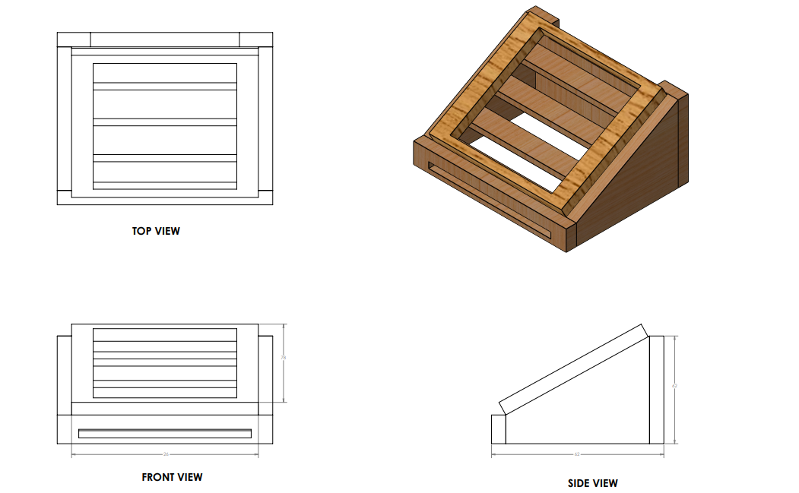

**FIGURE 3**

##### 

##### FIGURE 4

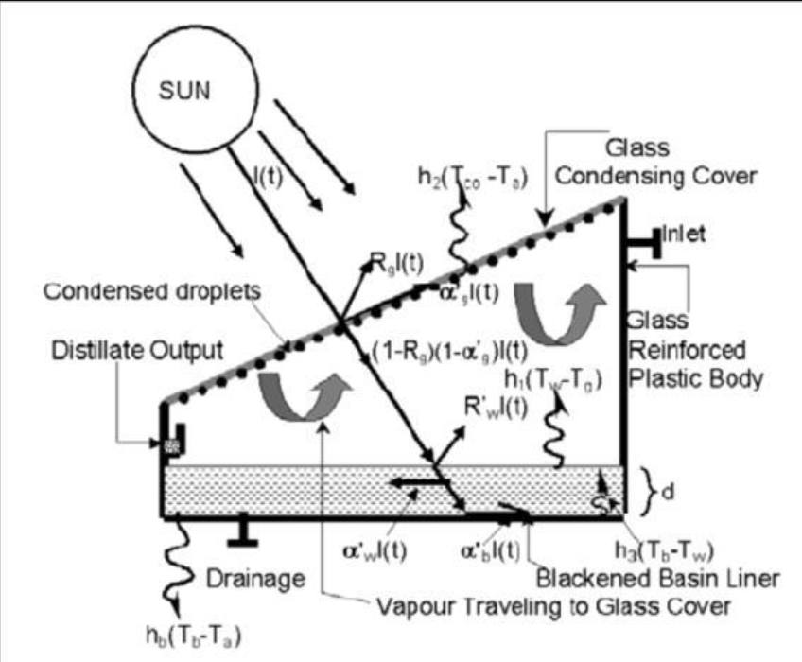

FIGURE 5

**3.5 DESIGN CONSIDERATION**

The designed and constructed solar dryer consists of two major compartments or chambers being integrated together, the solar collector compartment, which can also be referred to as the air heater, and the drying chamber, designed to accommodate three layers of drying trays on which the produces (or fruits) are placed for drying.

In this solar dryer constructed, the greenhouse effect and thermosiphon principles are the Theoretical basis. There is an was done in the month of April- May, the dryer was placed outside with the collector facing the sun. The collector has been rigidly fixed to the dryer at an angle of 17.5° to the horizontal to obtain approximately perpendicular beam of sun rays. The drying chamber was loaded with apple chips estimated to weigh averagely 50g of 6mm and 5mm thickness respectively. Under no load condition, the temperature of the heated air inside the dryer, the collector chamber and the ambient air was taken every one hour interval, starting from 9am to 6pm, and also in the absence of an hygrometer two thermometers were used to measure the relative humidity, where one thermometer has its sensor whirled with a weak, with the weak touching water in a beaker to get the wet bulb temperature , and the other thermometer provided the normal temperature which gives the dry bulb temperature. The wet bulb and dry bulb temperature were used to obtain the relative humidity on the psychometric chart, this was done every one hour interval, starting from 9am to 6pm.

A digital thermometer was used for the temperature measurement in the solar dryer ,the initial moisture content was measured using variation in weight loss was measured using an electronic scale.

**CHAPTER 4**

**CALCULATION**

##### CHAPTER 4

##### Insolation on the Collector Surface Area :

##### A research obtained the value of insolation for Abeokuta i.e. average daily radiation H on horizontal surface as; [10]

##### H =1350 W/m2a

##### and average effective ratio of solar energy on tilted surface to that on the horizontal surface R as;

##### R = 1.0035

##### Thus, insolation on the collector surface was obtained as ,Ic= HT = HR = 1350 × 1.0035

##### = 1354 W/m2

##### Determination of Collector Area and Dimension :

##### The mass flow rate of air Ma was determined by taking volumetric flow rate,

##### Thus, volumetric flow rate of air V'a = 75 m3 /hr.

##### V'a = 75/3600 = 0.02083 m3 /s.

##### Thus mass flow rate of air:

##### Ma = V’a × ρa

##### Density of air ρa is taken as 1.21kg/m3

##### Ma = 0.02083 × 1.21 = 0.0252 kg/s

##### Therefore, area of the collector AC

##### AC = (0.0252 × 1005 × 50)/(0.5 × 1354) = 1.75m2

##### The length of the solar collector (L) was taken as;

##### L = Ac/B = 1.75/1 = 1.75 m

##### Thus, the length of the solar collector was taken approximately as 1.75m.

##### Therefore, collector area was taken as (1.75 × 1) = 1.75 m2

##### Determination of the Base Insulator Thickness for the Collector :

##### The rate of heat loss from air is equal to the rate of heat conduction through the insulation. The following equation holds for the purpose of the design.

##### macp (T0 – Ti) = 10 × Ka(Ta - Ta)/tb

##### K = 0.04Wm-1K-1 which is the approximate thermal conductivity for Glass wool.

##### T0 = 80ºC and Ti = Ta = 30ºC approximately

##### Ma= 0.0252 Kgs-1

##### Cp = 1005 JKg-1K-1 and Ac = 1.75 m2

##### tb =[0.04 × 1.75 × (80-30)]/[0.1×.0252×1005×(80-30)] = 0.0270

##### = 2.70 cm

##### For the design, the thickness of the insulator was taken as 5 cm. The side of the collector was made of wood, the loss through the side of the collector was considered negligible.

1. **Moisture loss (M.L.)**:

* M.L = (Mi – Mf)/ Mi

Where , Mi = mass of sample before drying

Mf = mass of sample after drying

**For Chickoo** :

M.L = (850 – 240)/ 850 = 71.76 %

**For Banana** :

M.L = (700 - 130)/ 700 = 81.42 %

#### CHAPTER 5

#### FABRICATION

#### AND

#### ASSEMBLING

#### 

#### CHAPTER 5

#### The solar fruit dryer was constructed making use of locally available and relatively cheap materials. Since the entire casing is made of wood and the cover is glass, the major construction works is carpentry works (joinery).

#### The following tools were used in measuring and marking out on the wooden planks:

#### • Carpenter’s pencil, Steel tapes (push-pull rule type)

#### • Steel meter rule, Vernier caliper.

#### • Steel square, Scriber.

#### The following tools were also used during the construction;

#### • Hand saws (crosscut saw and ripsaw), Jack plane.

#### • Wood chisel, Mallet.

#### • Hammer and pincers.

#### The construction was made with simple butt joints using nails as fasteners and glue (adhesive) where necessary. The construction was sequenced as follows for the wood work:

#### • Collect three wood ply of 18 mm thickness.

#### • Marking out the lines as per the cutting requirement.

#### • Cutting out the already marked out parts.

#### • Planning of cut out parts to smoothen the surfaces.

#### • Joining and fastening of the cutout parts with nails and glues.

#### Put four partition of wood on the base of heating chamber of 5 cm at the equal interval. Filling the gap with glass wool as insulation of 5 cm.

* Covering the glass wool by the aluminium sheet of 27 gauge thickness and sheet is fastened to the heating chamber. 5 passings are made by placing wooden ply of 10 cm height on the aluminium sheet at the equal interval.
* Equal length of slots are cut out at alternate ends in the wooden ply. Cut out hole in the heating chamber at the entrance of the heating chamber. The size of the hole is equal to the outlet of the blower. Another hole is made in both the chamber for passing the air from heating chamber to drying chamber directly.
* The alluminium sheet was used of 27 gauge thickness. It was cut to the size of 175 × 100cm to minimize the top heat loss. It was painted black with for maximum absorption and radiation of heat energy.
* All inner side of the drying chamber are covered with glass wool of 5 cm thickness for minimize the heat loss from the drying chamber and glass wool is covered by the aluminium foil of 47 gauge.
* The glass was cut into size of 175 × 100 cm size. It is added as the solar collector’s cover. It is fitted by the silicon glue for the air tightening the chamber. The glass used was clear glass with 8 mm thickness.
* The trays were made with wooden frames permit free flow of air within the drying cabinetThree trays were used with average of 36 22.5 cm spacing arranged vertically one on top of the other, the tray size was 50 × 86 cm.
* The interior of the solar fruit dryer was painted black to promote absorption of heat energy. fit six wood strip for supporting the trays. Make some holes in the roof of drying chamber for exhausting the hot air in to the atmosphere.

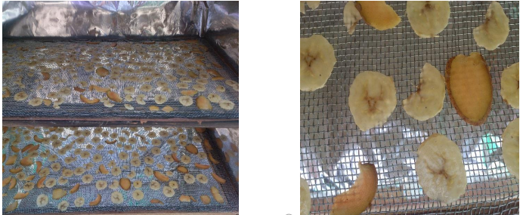

FIGURE 5.1 – BEFORE DRYING

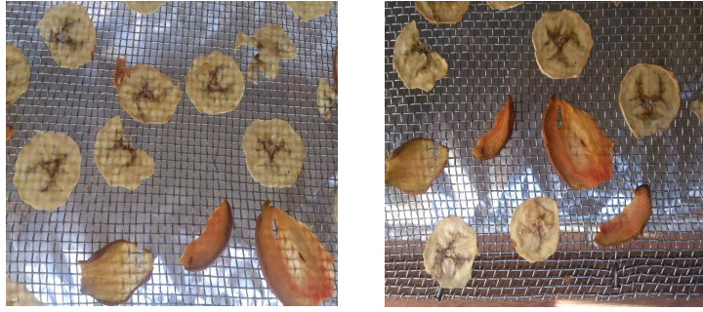

* FIGURE 5.2 – INTERMIDIATE & AFTER DRYING
* FINAL PROJECT PHOTO :

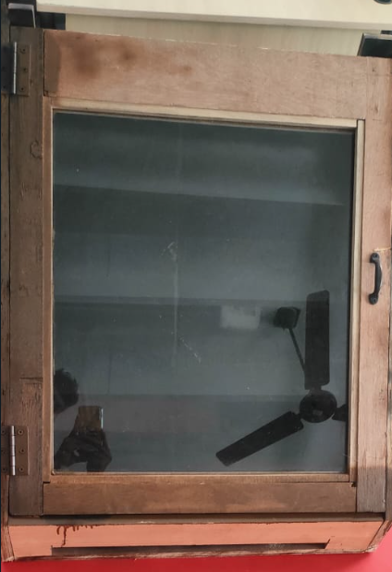

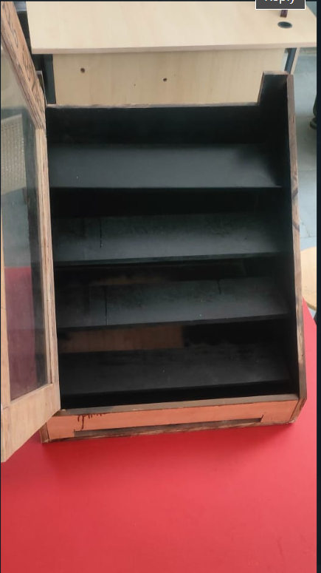

**CHAPTER 6**

**PROJECT**

**COST CALCULATION**

**CHAPTER 6**

* **FABRICATION COST [C1]:**

Wood Material = ₹ 1360

Extra work cost = ₹ 250

* **GLASS [C2]:**

Cost of Glass, Fitting = ₹ 1050

* **TRAY [C3]:**

Cost of the tray and it’s framing = ₹ 200

* **PAINT AND SOLUTION [C4]:**

Total cost of paint and solution = ₹ 750

* **TRANSPORTATION COST [C5]:**

Cost of transporting Model and Glass = ₹ 150

* **EXTRA COST [C6]:**

Extra cost = ₹ 600

* **TOTAL COST [C7] :**

Total cost of Fabrication Solar Dryer

(C1+ C2+ C3+C4+C5+C6+C7)  = ₹ 4,360

**CHAPTER 7**

**TESTING**

* As we describe earlier our basic purpose is to achieve70 to 80ºc temperature at the inlet of the drying chamber and reduce moisture upto minor level
* After assembling both the chamber , we fit the blower in the inlet of the heating chamber.
* The required reading are taken as follows :

**Without blower :**

Ambient temperature = 35ºc

Outlet temperature of heating chamber = 70ºc

TABLE 7.1 – INSIDE TEMPRATURE OF THE SOLAR DRYER

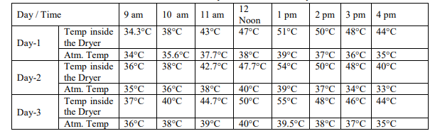

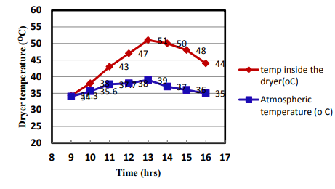

FIGURE 7.1 - TEMPREATURE MEASUREMENT IN OC INSIDE THE

DRYER ON DAY - 1

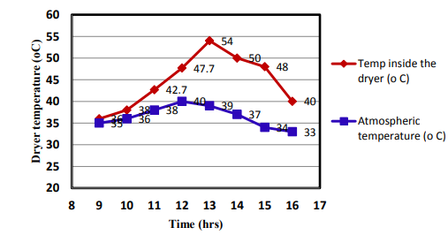

FIGURE 7.2 - TEMPREATURE MEASUREMENT IN OC INSIDE THE

DRYER ON DAY - 2

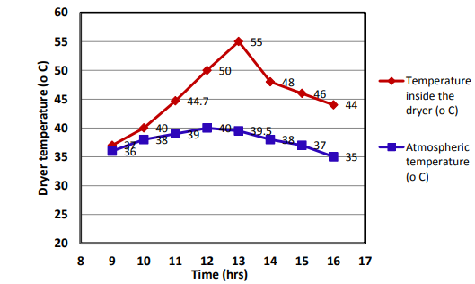

FIGURE 7.3 - TEMPREATURE MEASUREMENT IN OC INSIDE THE

DRYER ON DAY - 3

TABLE 7.2 - DIFFERENT TEMPRATURE AT DRYER TRAYS

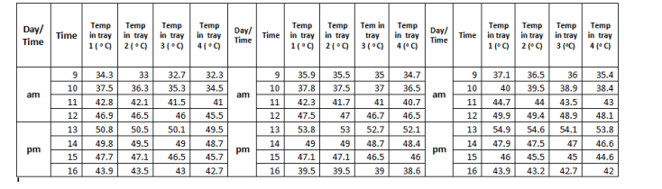

**CHAPTER 8**

**CONCLUSION**

**CHAPTER 8**

* The performance of existing solar fruit dryers can still be improved upon especially in the aspect of reducing the drying time and probably storage of heat energy within the system. Also, meteorological data should be readily available to users of solar products to ensure maximum efficiency and effectiveness of the system.
* Such information will probably guide a local farmer on when to dry his agricultural produce and when not to dry them.  Solar radiation can be effectively utilized for drying of agricultural produce in our environment if proper design is carried out.
* This was demonstrated and the solar dryer designed and constructed exhibited sufficient ability to dry agricultural produce most especially fruit items to an appreciably reduced moisture level.
* This will go a long way in reducing fruit wastage and at the same time fruit shortages, since it can be used extensively for majority of the agricultural fruit crops. Apart from this, solar energy is required for its operation which is readily available in the tropics, and it is also a clean form of energy.
* It protects the environment and saves cost and time spent on open sun drying of agricultural produce since it dries fruit items faster.
* The fruit items are also well protected in the solar dryer than in the open sun, thus minimizing the case of pest and insect attack and also contamination.
* Solar dryer according to the design eliminates unhygienic traditional way of drying food in open lands receptive to contaminants.
* Further the enhanced dryer, eliminates large place for drying, further being provided with holders that has enough capacity for large amounts of food to be dried. The enhanced solar dryer improves drying efficiency resulting in increased market value to the products.
* Solar drying technology involves exposing food to sunlight, while air flowing past the food to remove the moisture content from the food naturally. The warmer the air, the more moisture it can remove from the food.
* The solar dryer of the present work facilitates quick drying of the material to be dried. It can be seen that the percentage of weight reduction is more in case of dryer with a less time as compare with the fish dried in open sunlight.
* The temperature inside the drying chamber increases up to 51 o C while the atmospheric temperature is 34o C so that the efficiency of the dryer increases. It works throughout the year. It can work at night and during rainy season by burning biomass under the dryer.
* During daytime it can be heated up by direct solar radiation. It can be easily assembled and disassembled. It is light weight for transportation purpose and also low maintenance cost.

**CHAPTER 9**

**REFRENCES**

**CHAPTER 9**

**REFERENCE**

* Heat and Mass transfer by R .K. Rajput.
* Heat and Mass transfer by Books India publication.
* Alternate Energy Sources by Tech-Max publication.
* Thermodynamics by S.chand publication.
* www.iris.lib.neu.edu
* www.independentscience.blogspot.com
* **S. B. Heaters, Nirmalnagar, Bhavnagar.**
* **Raj furniture,pirchalla sheri,Bhavnagar**
* Adegoke, C.O and Bolaji, B.O. 2000. Performance evaluation of solaroperated thermo syphon hot water system in Akure, International Journal of Technology. 2(1): 35-40
* Akinola, A.O; and Fapetu, O.P. 2006. Exergetic analysis of a mixedmode solar dryer. Journal of Solar Energy and Applied. Science. 1 : 205- 10.
* Alamu, O.J; Nwaokocha, C.N and Adunola, O. 2010. Design and construction of a domestic passive solar food dryer, Leonardo Journal of Sciences, p. 71-82.
* Bahnasawy, A.J and Shenana, J.R. 2004. Evaluation of a solar crop dryer for rural applications in Botswana. Botswana Journal Technology 11(2): 58-62.
* Bena, B and Fuller, R.J. 2002. Determination of the average coefficient of internal moisture transfer during the drying of a thin bed of potato slices. Journal of Food Engineering. 48(2):95-101.
* Bolaji, B.O. 2005. Performance evaluation of a simple solar dryer for food preservation. Proc. 6th Ann. Engineering. Conf. of School of Engineering and Engineering Technology, Minna, Nigeria, pp. 8-13.
* Ericson, J. 1980. Global solar radiation measurements in England. Renewable Energy, 30(3)
* Kurtbas, I and Turgut, E. 2006. Experimental investigation of an indirect type natural convection solar dryer. Energy Conversion and Management, 43(16): 2251-2266 Sebaii, S; Balladin, D.A and Headley, O. 2002. Solar dryer with thermal storage and biomass backup heater, Solar Energy, vol. 81, pp. 449-462, 2007.
* Weiss, W. and Buchinger, J. , Solar drying,www.aeeintec.at/0uploads/dateien553.pdf
* Doua, P., Kapseu, C. and Kuitche, A. (2014). An Overview of Moisture Removal Mechanisms in Smallscale Dryers. International Journal of Research Studies in Science, Engineering and Technology, 1(3), 18-33.
* Mohsin, A.S.M., Maruf,N.I.Md., Sayem A.H.M., Mojumdar R.R.Md. and Farhad H. M. S. (2011).Prospect and Future of Solar Dryer: Perspective Bangladesh.IACSIT